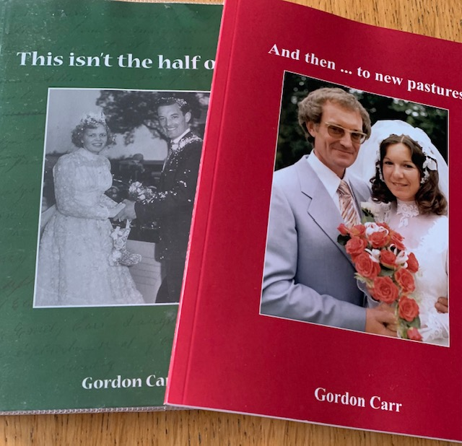
Oct 21

Gordon Carr has recently published the second volume of his autobiography. Gordon was born in 1933 in Thorner and spent his childhood and the war years around the villages in north Leeds. Some of our older residents are still friends with Gordon, and some of Gordon’s family still live locally. Gordon’s life story takes us from his early years and National Service to becoming a scrap dealer, an international motor cycle competitor, a tour operator, and a hill farmer in Bronte country and then Malhamdale.
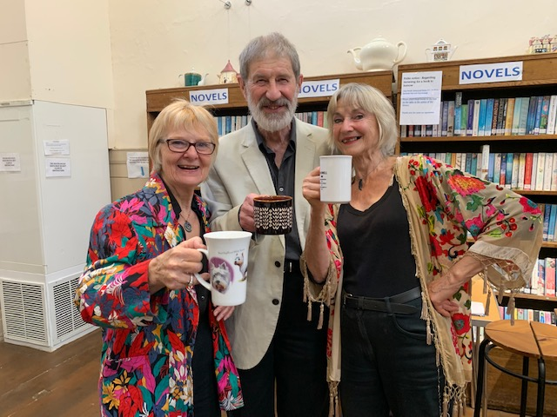
Both books can be borrowed from the Library and are well worth reading.

We were very pleased to be part of the Heritage Open Day events again this year. Trio Literati gave us a very enjoyable and entertaining performance of ‘Edible England’. There were lots of poetic treats, savoury and sweet, from John Keats to local poet Linda Marshall, and the funny fantasies of Roger McGough. Unfortunately this was our first event since Covid so we had to restrict numbers, but all who attended had a very good time.

It is really great news that the Cafes are open again. The Hardback Cafe, Fridays 12-3pm, and the first and fourth Tuesday of every month 11am-2pm. Ring the Library on the morning to book Tel 2656450. Sweet Memories is open two Tuesdays every month. Ring Pam 07761 288133 for details.

And more good news. Mary has started the Wednesday morning children’s sessions again. Parents/carers and toddlers welcome 10am-12pm for activities and refreshments.

A number of books haven’t been returned since lockdown. If you have any outstanding books can you please bring them back to the Library. There is no payment due.

We are still looking for new and enthusiastic volunteers to join the Library Committee and our team of volunteers. If you are interested and would like to discuss the role further then please contact Debbie Tel 0113 2657575 or Olwen Tel 0794 6630 454

Events at the Library
History talk. Emma Storr: A Little Bit of What you Fancy: diets, remedies and recipes from the past. Hospital and workhouse diets in the nineteenth century and remedies made at home. Tuesday 9th November 7.30pm. £5 inc refreshments.
Booking e mail: denise.trickett@btinternet.com or Tel 0785 0283 529
Monthly Scrabble sessions. Next date is Wednesday 10th Nov 1.30pm - 4pm. All welcome, just turn up.
Library AGM Tuesday 23rd November 17.00pm All welcome.
Local History Quiz by Robert Dyson Tuesday 30th November 7.30pm Fun, mince pies and refreshments £5. Booking e mail: denise.trickett@btinternet.com or Tel 0785 0283 529

Denise Tricket

